Train vs. Validation vs. Test set
For training and testing our model, we should have our data broken down into three distinct dataset splits.
- The Training Set
It is the set of data that is used to train and make the model learn the hidden features/patterns in the data. The training set should have a diversified set of inputs so that the model is trained in all scenarios and can predict any unseen data sample that may appear in the future.
- The Validation Set
The validation set is a set of data, disjoint from the training set, that is used to validate our model performance during training. This validation process gives information that helps us tune the model’s hyperparameters and configurations accordingly. It provides input regarding whether the training is moving in the right direction or not.
The main idea of splitting the dataset into a validation set is to prevent our model from overfitting i.e., the model becomes really good at classifying the samples in the training set, data it has "seen", but cannot generalize and make accurate classifications on the data it has not seen before.

The Test Set
The test set is a separate set of data used to test the model after completing the training.
It provides an unbiased final model performance metric in terms of accuracy, precision, etc. To put it simply, it answers the question of "How well does the model perform?"
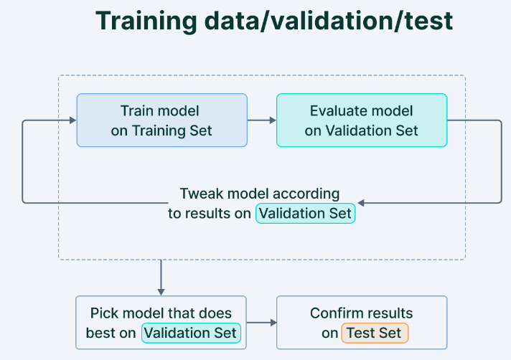

How is Machine Learning data split?
The dataset split ratio depends on the number of samples present in the dataset and the model. When there is a lot of data, an 80/20 or even 90/10 split can be used. When there are more modest amounts of data, a 70/30 split is common.
Some common inferences that can be derived on dataset split include:
- If there are several hyperparameters to tune, the machine learning model requires a larger validation set to optimize the model performance. Similarly, if the model has fewer or no hyperparameters, it would be easy to validate the model using a small set of data.
- With the increase in the dimension/features of the data, the hyperparameters also increase making the model more complex. In these scenarios, a large split of data should be kept in training set with a validation set.
The truth is—
There is no optimal split percentage.

Techniques for data splitting
Various data splitting techniques have been implemented in the Computer Vision literature to ensure a robust and fair way of testing machine learning models. Some of the most popular ones are explained below.

Random
Random sampling is the oldest and most popular method for dividing a dataset. As the name suggests, the dataset is shuffled, and samples are picked randomly and put in the train, validation, or the test set based on what percentage ratio is given by the user.
However, this method has a significant drawback. Random sampling works well on class-balanced datasets, i.e., datasets with roughly the same number of samples in every dataset category. In the case of class-imbalanced datasets, such a data splitting method may create a bias.
For example, if a dataset has 1000 images, of which 800 are dog images and 200 are cat images, random sampling using an 80%-20% ratio might result in the training set consisting of only dog images, while the validation set consists of only cat images. Even if it’s not so extreme, there will still be an imbalance distribution among the train and validation sets.

Stratified
Stratified sampling solves this problem to some extent. Here, the distribution of classes in each of the train, validation, and test sets is preserved.
Suppose a dataset consists of 1000 images, of which 800 are dog images and 200 are cat images. Stratified sampling ensures that the training and validation sets have 80%dog images and 20% cat images.
Stratified sampling is, thus, a more fair way of data splitting, such that the machine learning model will be trained and validated on the same data distribution.

Cross-Validation
Cross-Validation or K-Fold Cross-Validation is a more robust technique for data splitting, where a model is trained and evaluated “K” times on different samples.
Suppose we have a balanced, 2-class dataset consisting of 1000 images of dogs and cats (to be used for training and validation only). Now, we want to perform a 5-Fold cross-validation. We first split the datasets into 5 equal and non-overlapping parts: each consisting of 200 images; label them as Parts a, b, c, d, and e.
Now, we will create 5 complete datasets (labeled as Datasets A, B, C, D, E) using Parts a-e as follows: For Dataset A, use Part a as the validation set, and the union of Parts b-e to create the training set; for Dataset B, use Part b as the validation set, and the union of Parts a, c, d and e to create the training set, and so on. Notice that since each part consists of 20% of the data of the original dataset, each of Datasets A-E has an 80%-20% train-validation split ratio. Generalizing, each K-Fold cross-validation dataset has (100/K)% data in its validation set (here, 100/5 = 20% was in validation set).
Using K-Fold cross-validation exposes the machine learning model (trained independently of each other) to different distributions of data (“K” times to be exact). This alleviates any bias that may occur while selecting data in the training and validation sets. Average and standard deviation values are usually reported while using K-Fold cross-validation schemes.
A little thought shows that K-Fold cross-validation also suffers from the same problem as random sampling. Data distribution may get skewed when the “K” parts or subsets of the datasets are created. In the example above, it may so happen that Part B of the dataset consists of 200 images of dogs and no images of cats.
Thus, the “Stratified K-Fold Cross-Validation” technique avoids such inconsistencies. Similar to stratified sampling, the class-ratio of the data is maintained while generating the “K” subsets or parts of the data. Thus, the same class distribution is carried forward when these “K” parts are coalesced to form the final complete datasets.

3 common pitfalls in the training data split

Low-quality training data
The quality of the training data is crucial for the model performance to improve.
If the training data is “garbage,” one cannot expect the model to perform well.
Moreover, since the machine learning algorithms are sensitive to the training data, even small variations/errors in the training set can lead to significant errors in the model performance.

Overfitting
Overfitting happens when the machine learning model memorizes the pattern in the training data to such an extent that it fails to classify unseen data. Thus it performs well on the training set but poorly on the validation and testing sets.

Validation and Test Set metrics
The validation set metric is the one that decides the path of the training of the model and must be chosen carefully.
Metrics should be chosen so that they bring a positive effect on the overall trajectory of the model performance.

